TECHNICAL SPECIFICATIONS FOR ELECTRONIC STORAGE AND
TELEMATIC TRANSMISSION OF THE DATA OF THE DAILY FEES
AS PER ART. 2, PARAGRAPH 1, OF LEGISLATIVE DECREE NO. 127 OF 5 AUGUST 2015

Version 10 June 2020
INDEX
- PURPOSE OF DOCUMENT 5
- TECHNICAL CHARACTERISTICS OF THE INSTRUMENTS THROUGH WHICH
ELECTRONICALLY STORE AND TELEMATICALLY TRANSMIT THE
DATA OF FEES PURSUANT TO ART. 2, PARAGRAPH 1, LEGISLATIVE DECREE NO. 127/2015 7
  - HARDWARE AND SOFTWARE FEATURES 7
  - MODEL APPROVAL PROCESS 19
  - CERTIFICATION PROCESS FOR THE IDENTIFICATION OF

RT EQUIPMENT 19
2.4 ACTIVATING THE RECORDER 20
2.5 CHANGES IN THE STATUS OF THE TELEMATIC RECORDER 22
2.6 COMMISSIONING AND PERIODIC INSPECTIONS 25

2.7 DATA GENERATION AND TRANSMISSION 26
2.7.1 Daily fees 28
2.7.2 Commercial document for lottery purposes 30

2.8 EMERGENCY PROCEDURES 30
2.8.1 Absence of internet network and/or device connectivity problems (uploading
file extracted from RT) 31
2.8.2 Device out of service (data acquisition) 31
2.8.3 Discarded transmissions recovery 33
2.9 ONLINE BUSINESS DOCUMENT 34
2.10 ADAPTATION OF CASH REGISTER EQUIPMENT FOR ELECTRONIC STORAGE AND TELEMATIC DATA TRANSMISSION OF THE FEES 35

2.11 MANUFACTURERS OF TELEMATIC RECORDERS 37
- SUBJECTS WITH MULTIPLE CHECKOUT POINTS PER SINGLE POINT OF SALE 40
- TECHNICAL NOTES 44
  - SERVICES 44
  - DATA FORMAT 46

4.3 RESULT CODES

ATTACHMENTS: ATTACHMENT - API REST DEVICES

ATTACHMENT - API REST ERP

ATTACHMENT - DATA TYPES API DEVICES AND MANAGEMENT SOFTWARE

ATTACHMENT - DATA TYPES FOR FEES - VERSION 6.0 NOVEMBER 2017 (VALID UNTIL 31st DECEMBER 2020)

ATTACHMENT - DATA TYPES FOR FEES - VERSION 7- JUNE 2020

ATTACHMENT - DATA TYPES FOR INVOICE DATA

ATTACHMENT - CODE LIST

ATTACHMENT - TECHNICAL REQUIREMENTS FOR APPROVAL

ATTACHMENT - DGFE LAYOUT - FISCAL MEMORY

ATTACHMENT - COMMERCIAL DOCUMENT LAYOUT
GLOSSARY
AE System: Information system of the Revenue Agency.
ADM System: Information system of the Customs and Monopolies Agency.
Manufacturer certificate: certificate issued by the Revenue Agency to sign the device certificate application.
Device Certificate: certificate issued by the Revenue Agency for the signature of the data of the fees containing the unique identifier of the device.
Operator: the VAT taxable person who uses the Telematic Recorder and carries out the activity referred to in Article 22 of Presidential Decree no. 633 of 26th October 1972.
Electronic seal: data in electronic form, attached or connected by logical association to other data in electronic form, to guarantee the origin and integrity of the latter.
XML (Extensible Markup Language): type of format used for structured data exchange in client server applications.
Fiscal module: hardware and software component that manages the fiscal part of the Electronic Recorder or the collection of data for the purposes of storage and transmission of the fees and able to produce a file to which is affixed an advanced electronic seal in accordance with the provisions of EU Regulation n. 910/2014, which guarantees its origin and integrity.
Submission form: hardware and software component responsible for the signature and transmission of data in the formats provided for in this specification, useful for the adaptation of the current cash registers and external to them.
Server-RT: device equipped with fiscal module and telematic transmission capacity, equipped with unique fiscal identification and able to read, store and transmit data with fiscal value, connected to the individual cash points of a single point of sale. Cash Point" means a system located in the point of collection of the fees, while the Server-RT is always the first point where the fees are collected and is the tool that seals the files and sends them to the AE system.
Telematic Recorder: device equipped with fiscal module and telematic transmission capacity, with unique fiscal identification and able to read, store and transmit data for fiscal purposes. This category can also include cash registers produced on the basis of a provision of the Director of the Revenue Agency for the approval of the model, valid on January 1st, 2017, provided they are adapted to meet the technical requirements provided in this document for the Telematic Registrar.
Device identifier: unique key, device identifier, to be inserted in the xml file containing the fiscal data to be transmitted, when required, and to be used for the exposed services (device serial number).
Tax seal: physical seal affixed to the envelope containing the tax form in order to ensure its accessibility only to qualified technicians or the staff of the Financial Administration.
Qualified technician: subject qualified in accordance with UNI EN ISO 9001:2000, to carry out the periodic verification activity currently provided for fiscal meters. The periodic verification of fiscal meters can be carried out by laboratories and manufacturers as long as they are included in the list published on the website of the Revenue Agency. These subjects will also be involved in the operations necessary for the activation of the recorder at the operator, which concern the application for a certificate "device" and communication of the VAT number of the operator.

1. PURPOSE OF THE DOCUMENT
Article 2, paragraph 1, of Legislative Decree no. 127 of 5th August 2015, as amended by Article 17 of Legislative Decree no. 119 of 23rd October 2018, states that as from 1st January 2020, the persons who carry out the transactions referred to in Article 22 of Presidential Decree no. 633 of 26th October 1972, shall electronically store and transmit to the Revenue Agency the data relating to daily fees. The electronic storage and the related transmission of the data of the fees replace the registration obligations referred to in article 24, first paragraph, of the above mentioned decree no. 633 of 1972. The provisions of the previous periods shall apply as of 1st July 2019 to persons with a turnover exceeding 400,000 Euro. For the 2019 tax period, the options for the electronic storage and telematic transmission of the data of the fees exercised by 31st December 2018 remain valid.
The aforementioned Article 2 also establishes, in paragraph 3, that electronic storage and telematic transmission must be carried out by means of technological instruments that guarantee the authenticity and inalterability of the data, including those that allow payments by debit and credit card and, for this purpose, in paragraph 4, that by order of the Director of the Revenue Agency, after consulting the trade associations, the information to be transmitted, the technical rules, the terms for telematic transmission, the technical characteristics of the technological instruments with approval of the relative models and any other provision necessary for the implementation of the aforesaid provisions are defined.
In addition, article 18 of legislative decree no. 119 of 23rd October 2018 amended the provisions previously set out in article 1, paragraph 540 of law no. 232 of 11th December 2016 concerning the "Lottery of Fees", the latter paragraph was amended by article no. 141 of the Relaunch Decree of 19th May 2020, no. 34, modifying the deadline for the entry into force of the lottery of fees to 1st January 2021.
In particular, from 1st January 2021, taxpayers, natural persons of legal age residing in the territory of the State, who make purchases of goods or services, outside the exercise of business activities, art or profession, from operators who transmit the fees electronically, pursuant to Article 2, paragraph 1, of Legislative Decree 5th August 2015, n. 127, may participate in the lottery draw of prizes awarded as part of a national lottery.
In addition, paragraph 1, point c) of the same article states that by order of the Director of the Customs and Monopolies Agency, in agreement with the Inland Revenue, the technical procedures relating to extraction operations as well as any other provision necessary for the implementation of the lottery are regulated.
This document defines the technical specifications of the technological tools referred to in art. 2, paragraph 3, of Legislative Decree no. 127/2015 through which to operate the electronic storage and transmission of data referred to in paragraph
1 of the same decree; by order of the Director of the Revenue Agency of 31st October 2019 the technical rules for the transmission of the data necessary for the implementation of the above mentioned lottery, the identification of the information to be transmitted and their format have been defined.
This document defines the mechanisms and procedures aimed at guaranteeing the authenticity and integrity of the data stored and transmitted in accordance with paragraph 1, art. 2, of Legislative Decree no. 127/2015 and is based on the certification processes of hardware and software components of the existing or newly produced recording tools.
The system defined in this document also establishes the services through which operators in the sector (hardware manufacturers and software producers) and VAT taxable persons who are owners of the Telematic Recorders will be able to manage the process and monitor the transmitted flows. The system makes available user interfaces and exposed services to be called by the hardware/software components of the devices.
With subsequent measures of the Director of the Revenue Agency may be defined the technical specifications of additional technological tools referred to in Article 2, paragraph 3, of Legislative Decree no. 127/2015 through which to operate the electronic storage and telematic transmission referred to in paragraph 1, the identification of the information to be transmitted and their format.

2. TECHNICAL CHARACTERISTICS OF THE INSTRUMENTS BY MEANS OF WHICH TO ELECTRONICALLY STORE AND TRANSMIT THE DATA OF THE FEES PURSUANT TO ART. 2, PARAGRAPH 1, LEGISLATIVE DECREE NO. 127/2015

2.1 HARDWARE AND SOFTWARE FEATURES

TELEMATIC RECORDERS
- The technological tools through which the electronic storage and telematic transmission referred to in art. 2, paragraph 1, of Legislative Decree no. 127/2015 are defined as "Telematic Recorders".
- The Telematic Recorders are tools made by hardware and software components suitable to record, store, process and transmit telematically the fiscal data introduced through input devices, as well as other hardware and software elements including, necessarily, a device for printing and one for display. The printing and visualization of the data must ensure easy readability for users. The printed and displayed data are controlled by the tax form.
Telematic recorders are suitable to store, in permanent and unalterable memories, the detailed data and the summary data of the operations carried out following the transfer/performance, as well as their transmission in an authenticated, protected and secure way using the public network.
- Each model of Telematic Recorder is uniquely identified by a "serial number" combined with a "fiscal logo" (identification mark for fiscal purposes of each model of Telematic Recorder, consisting of the abbreviations RT followed by the serial number of the Recorder), both attributed with the measure of approval of the relative model. The serial number of each model consists of a group of eleven characters composed as follows:
A/N A/N A A/N A/N N | N N N N
The first two characters can be alphabetical or numerical and identify the manufacturer; the third, alphabetical, identifies the scope of use or functionality of the recorder ("I" stands for indoor use; "E" stands for outdoor use; "P" stands for handheld recorder; "M" stands for Adapted cash register [see par. 2.8]; "S" stands for Server / RT [see par. 3]). The following two alphanumeric numbers identify the model. The last six characters are numeric and constitute a progressive numbering with alignment on the right and with zeros filling on the left if the number consists of less than six digits.

FISCAL FORM
The Telematic Recorders guarantee the authenticity and inalterability of the fiscal data registered by them and, for this purpose, they are provided with a special "fiscal form".

The "tax form" is composed of:
- a "non-alterable memory" (read-only) containing a program ("fiscal firmware") for the exclusive management of fiscal data, separated from the management software from a logical and functional point of view;
- a special processor that executes at least the "fiscal firmware";
- a "permanent memory" that cannot be rewritten to contain fiscal data;
- a "working memory" able to contain temporary data before their consolidation in the permanent memory.
The "permanent memory" is divided into two components: the "summary" memory and the "detail" memory, both allocated within the envelope containing the tax form and protected by the tax seal in order to guarantee its inaccessibility.
The "summary" memory is immovably fixed to the structure of the Telematic Recorder and protected by thermosetting resin which guarantees its inaccessibility and immovability.
In order to be able to update the fiscal firmware, contained in the special "non-alterable memory" connected to the processor that performs it, without the need for the authorized technician to remove and affix the fiscal seal again, the fiscal firmware is signed by the manufacturer through the certificate of signature, issued by the Revenue Agency (called "Manufacturer's Certificate" in paragraph 2.3). The fiscal firmware thus signed must be attached to the model approval application sent to the Agency.

In this case, subsequent updates of the fiscal firmware (both locally and remotely by qualified technicians) must be electronically signed by the manufacturer and approved by the Agency in order to be valid; moreover, any changes to the fiscal firmware must be noted in the permanent summary memory. Finally, this operation must be reported in the first transmission of the daily fees made by the Telematic Recorder or RT-Server after the software update operation, indicating the "code 06 - other" in point 6.4 of the track reported in the attachment "Attachment - Data Types for Fees - version 7 - June 2020", and specifying in the explanatory note that it has "Carried out the update of the fiscal firmware - Version ... - Measure no... of ...".

If the firmware update concerns aspects that are not fiscally relevant (e.g. mere bugs, performance improvement, etc.), since a variant request is not necessary, the manufacturer, before making the new version of the software available, must exclusively send to the Inland Revenue, together with the signed new firmware version, a declaration with assumption of responsibility for the changes made to the software, stating at least the following elements:

- the details of the eligibility measure already issued by the Revenue Agency;

- the analytical description of the changes made to the software with the technical intervention object of the communication;

- the declaration, made pursuant to Article 47 of Presidential Decree no. 445 of 28th December 2000, that the system complies with the requirements of the provision of the Director of the Revenue Agency of 28 October 2016 and the related technical specifications;

- the declaration, made pursuant to Article 47 of Presidential Decree 445/2000, that the changes made to the system do not affect the level of fiscal guarantee.

The Commission for the approval of fiscal measuring devices assesses the actual non-relevance for tax purposes of the declared changes. After hearing the opinion of the Commission, the Agency may request the certification of the interventions as well as, in the most serious cases, the withdrawal of the approval pursuant to Art. 3 of the Ministerial Decree of 23 March 1983. Also these changes must be noted in the permanent summary memory and must be reported in the first transmission of daily fees made by RT/Server-RT after the software update operation, indicating the "code 06 - other" in point 6.4 of the path reported in the attachment "Annex - Data Types for Fees version 7.0 - June 2020", and specifying in the explanatory note that it has been "Carried out the update of non-fiscal software - Version ...". - Declaration no. of ...".
A special intervention code ("07" Software Update) has been provided in the attachment "Attachment - Data Types for Fees version 7.0 - June 2020" to communicate this type of intervention. There are also two specific fields, 6.5<NumberSw> and 6.6<DataRelease>, to indicate the version and date of the software with which the fiscal firmware has been updated.
The Telematic Recorder or RT-Server when it is put into service will have to send the information related to the fiscal firmware version present on the device.
For this purpose, in the first useful transmission of the fees, as indicated in the attachment "Attachment - Data Types for Fees version 7.0 - June 2020", the field 6.4 <Code > with the value "07" will be valorized and the two appropriate fields 6.5<NumberSw> and 6.6<DataRelease> will be filled in to indicate the version and date of the fiscal firmware software on the device.

The fiscal firmware is clearly and univocally identified by a system of identification of the firmware versions which must include a progressive number and the date of release, expressed in the format year month day.

The TELEMATIC RECORDER must always allow the display of the fiscal firmware version installed on the device.
Suitable software procedures verify the integrity of tax data stored in the permanent summary and detail memory. If the verification of the integrity of the fiscal data gives a negative result, the system interrupts its operation, provides a specific report to the operator and transmits a suitable report to the AE system according to the appropriate "Device Event" path, in the attachment "Attachment - API Data Types Devices and Management". The AE system will record the report and set the status of the device to "out of service". The device will return to service with the first successful transmission, without any reactivation.
In the absence of an external power supply, a suitable buffer battery guarantees the maintenance of the data contained in the working memory.
With special commands from input devices it must be possible to request the reading and printing, even virtual, of at least the following information contained in the permanent summary memory:
- integral content of the permanent summary memory;
- content related to daily closures between two assigned order numbers;
- content related to daily closures between two assigned dates;
- sum of the daily fees between two assigned dates.
Similarly, it must be possible to request the reading and printing, even virtual, of at least the following information contained in the permanent detail memory:
- integral content of the permanent detail memory;
- content relating to operations between two assigned dates;
- content related to the operations identified by document number related to a single operation;
- content relating to operations between two assigned document numbers;
- content related to the outcome of the transmission between two assigned dates.
Memory reading and daily closing operations must be recorded in the Telematic Recorder with the management document counter.
The telematic recorder (or the RT Server) allows the operator to regulate the access, even remotely, to the data contained in the permanent detail and summary memory. At any time, it must be possible to inhibit or enable the reading, export and reprint, even virtual, of the data contained in the two memories.
To ensure the necessary clarity and recognizability, the header must indicate the name "Management Document" and it must contain the date of processing, the serial number of the Recorder and the required parameters.
The eventual disconnection of the permanent summary and detail memory from the processor that executes the fiscal firmware is detected, when the machine is turned on, through the software; moreover, in this hypothesis, following the subsequent turning on of the device, the qualified technician intervenes with a total reset, to restore the operation of the device.
A possible failure of the permanent memory is diagnosed by the Telematic Recorder and reported with an appropriate message to the operator. At the same time, the system interrupts its operation and transmits a suitable signal to the AE system according to the appropriate path "Device Event", in the attachment "Attachment - API Data Types Devices and Management", using the detail code "00600" Memory exhausted after the event "OUT_OF_SERVICE". Please note that if the failure does not compromise the
"device certificate" is not necessary to apply for a new certificate nor are additional tax requirements necessary. The AE system will record the report and set the device status to "out of service". The device will return to service with the first successful transmission, without any reactivation.
A possible failure of the permanent summary memory that compromises, instead, the use of the "device certificate" is diagnosed by the Telematic Recorder and reported with an appropriate message to the operator. The operator, possibly also through the authorized technician or other delegated subject, makes a communication on the Inland Revenue website to report the failure using the detail code "00609" Summary memory exhausted or with compromised certificate in the event "DISMISSAL").
If it is necessary to replace the permanent summary memory, this operation is carried out by the manufacturer, who must renew the memory.
request for device certificate according to the following
paragraph "Certification process for the identification of RT equipment", after assigning a new serial number to the MCR. The old Telematic Recorder, identified by the old serial number, will have to be discontinued.
In both these last two cases, the operator must:
- promptly request the intervention of a qualified technician to repair the RT;
- report, also through the qualified technician, to the Revenue Agency about the RT malfunctioning through a specific online procedure
available on the Revenue Agency website.
- until its correct functioning is restored or if the point of sale is not equipped with another RT in service, take note on a special register of the data of the daily transaction fees.
Once exhausted or replaced, the permanent summary and detail memories must be kept for the period provided for in Article 2220 of the Italian Civil Code.
In the situation where the capacity of the permanent summary and detail memory is about to run out (no more than 90% of the capacity itself), suitable notification is provided to the user of the MCR.
Upon completion of the permanent summary and detail memory, the Telematic Recorder interrupts the execution of the functions with fiscal value, but in any case allows the reading and transfer of the contents of the aforementioned memory in xml format and according to the information contained in the document "Attachment - DGFE trace - Fiscal memory".
In case the detail memory is made up of a different module and separated from the summary memory, it can be removed in case of failure or exhaustion and replaced with another one having at least the same functional and reliability characteristics through the intervention of a qualified technician, after removal of the "tax seal" described below.
The permanent detail memory, which has the function of a background journal and contains the analytical data of each operation carried out, including also the information of the transmissions, is called "electronic background journal-device" (DGFE).
The "DGFE" is directly controlled by the fiscal firmware.
The DGFE ensures appropriate levels of fiscal guarantee and for this purpose is made on suitable physical means that ensures the inalterability of the data recorded under normal conditions of use, even outside the context of RT.
In order to guarantee a logical association between the data stored in the DGFE over time, and the MCR on which the detail memory is used, the following information is recorded on each DGFE during the initialization phase:
- DGFE identification code, progressive starting from the fiscal activation of the Telematic Recorder;
- Serial number of the Telematic Recorder;
- date and time of registration.
This initialization information is simultaneously stored in the permanent summary memory.
The summary memory contains suitable totalisation elements in order to store fiscal data. These elements allow:
- the progressive accumulation of the consideration related to each daily closure and the progressive count of the daily closures themselves;
- the processing of the daily total of the fees relating to the individual transactions carried out during the working day, including correction and adjustment operations. The daily total of the fees, after registration in the appropriate totalizer, and the subtotals are automatically zeroed at the daily closing, which determines the increase of one unit of the contents of the remittance register to zero;
- the progressive counting of the documents issued during each working day at the time of the generation of each document. The zeroing of the number resulting from this count is determined by the daily closing command.
The totalisation elements mentioned above are suitable for the operational needs and in any case guaranteed over time by means of a suitable buffer battery or by software systems able to guarantee the integrity of the working data.

CASING AND TAX SEAL
The Telematic Recorder is equipped with a casing made according to configurations and number of elements established by each manufacturer according to its production and market needs, provided that its inaccessibility is guaranteed. The case contains, in addition to the tax form, at least one printing station, excluding paper media.
In particular, the tax form is placed in a special slot, which in turn is contained in the aforementioned casing; the latter is secured by a "tax seal" affixed by the manufacturer at the end of the process of certification of the MCR referred to in point 2.3 below.
The tax seal consists of a self-adhesive plate, made of material that, upon removal, is destroyed and, in addition, in the central part must be transparent in order to make the locking system visible (eg screw) that blocks the casing in which the tax module is placed.
On the nameplate there is the RT symbol followed by the manufacturer's logo. The model of the plate used by the manufacturer complies with the characteristics provided for in Annex A of the Measure of the Director of the Revenue Agency of 6th May 2010.
With the affixing of the tax seal, the manufacturer certifies the conformity of the Electronic Recorder copy to the model approved by the Revenue Agency.
The tax seal of the Telematic Recorders in service can be removed only by the certifying bodies and, during the service and maintenance operations of the device, by qualified technicians. In both cases, the technician - at the end of their intervention and/or the activities of the Financial Administration - replaces the plate with a new one that meets the requirements specified above and bears the RT symbol followed by the logo of the laboratory to which the qualified technician belongs.
Manufacturers, when approving a new model of Telematic Recorder, can propose to the Revenue Agency technical-functional realizations of the tax seal different from those mentioned above, provided that the inaccessibility characteristics of the tax form are maintained.
The qualified technician records in the summary memory, together with their identification and that of the laboratory for which they work, the information related to the operation carried out as defined in table 9 of the attached "Attachment - Code List".
The operator as owner of the data present in the memories of the Telematic Recorder pursuant to art. 24 of the General Regulation on Data Protection 2016/679 must implement adequate technical and organizational measures in order to ensure the compliance of the processing with the Regulation itself.

COMMERCIAL DOCUMENT
The telematic recorders are able to print, even virtually, the commercial document defined by the ministerial decree referred to in Article 2, paragraph 5, of Legislative Decree no. 127 of 5th August 2015, respecting the printing layout defined in the "Attachment - Commercial Document Layout".
Commercial documents must always contain the following information, which uniquely identifies the individual:
- Device serial number, as information that uniquely identifies the device that issued the commercial document.
(Telematic Recorder serial number or Server-RT serial number with cash point serial number)
- Commercial document number, which is obtained by concatenating the closing number (4 digits) and the progressive number (4 digits), with a hyphen "-" separator between the two groups.
- Date of commercial document
- Operator's VAT number
In addition, if the consumer has provided the lottery code for participation in the Lottery of the fees, the Layout of the commercial document must contain this code.
The Telematic Recorder may have functions to correct operations carried out before the commercial document is issued; afterwards only the commercial document issued for cancellation or return can be used (see "Attachment - Commercial Document Layout (v4)") as specified in the following paragraph.
Finally, at the bottom of the commercial document - at least three lines after the fiscal logo and the serial number - can be inserted an "APPENDIX", possibly detachable, in which can be reported, if any, the data or images that the merchant deems appropriate for its business (advertising, graphic images, greetings and courtesy messages, informative and promotional messages for the customer, details of payment through POS, the specification of the types of payment, etc.).

In the case of fees not collected but for which the customer has provided the countervalue in meal vouchers, in the commercial document can be reported, purely figurative, the VAT rate of each product, although this VAT does not represent the actual tax on the individual transaction but will be purely figurative (in the case of meal vouchers, since it is a substitute service of the canteen, the rate of the supply of food and drink is applied).

COMMERCIAL DOCUMENT OF RETURN OR CANCELLATION
- Below is a description of the different ways to issue a commercial document of return or cancellation.
Case A) : Issue of return/cancellation documents on the same device from which the reference commercial document was issued
In order to proceed with the issuance of a return or cancellation document, a search for the commercial reference document must first be allowed in the permanent detail memory of the device, verifying the correspondence with :
  - the serial number of the device from which the commercial document was issued;
  - the identifier of the commercial document (composed of the progressive closing number followed by the progressive number of the commercial document). Depending on the result of the search, the following cases can be distinguished:

- A.1) If the search is successful, it must be possible to issue the commercial document :
    - per return, for an amount equal to or less than the capacity of each rate of the commercial document of reference;
    - to cancel, exclusively for an amount equal to that of the commercial document of reference, for each rate.
- A.2) If the search was unsuccessful, only if the date of the reference commercial document is earlier than the date of the first commercial document in the detail memory (case of the DGFE replaced), it must be possible to proceed with the issue of a document to cancel or return it in manual mode as described later in Case B).
Case B) : Issue of return/cancellation of a commercial reference document issued by another device (or on another DGFE)
If the commercial document was issued by another device (device serial number - RT or server-RT - different from the serial number printed on the commercial document of reference), or stored on a previous DGFE
(see case A.2), it must be possible to proceed with the issue of a cancellation or return document by entering the following information in manual mode, which will also be reported on the return/cancellation document :
- the device serial number of the reference document;
- the date of the commercial document to which reference is made;
- the identifier of the commercial document to which reference is made;
- the VAT rates of transactions subject to return/cancellation;
- the lottery code, if present in the commercial document of reference.

Case C) : Issue of return/cancellation documents using other evidence of purchase
As provided by Circular 3/E of 21st-Feb-20, it must be possible to proceed with the issuance of a document for cancellation or return also using other "elements that can confirm to the merchant the purchase, as in the case of the POS receipt or returnable spaces".
In such cases, it must be possible to proceed with the issuance of a cancellation or return document by entering the following information in manual mode, which will also be shown on the return/cancellation document:
- instead of the serial number of the device, a descriptive abbreviation :
    - "POS" in case of POS receipt;
    - "VR" in case of redeemable packaging;
    - "ND" in other possible residual cases (e.g. return/cancellation of tax receipt issued by Fiscal Meter orweb commercial document issued through the on-line procedure etc.). );
- the date of the operation referred to;
- the VAT rates of transactions subject to return/cancellation.

DATA CORRESPONDING TO VENDING MACHINES
Telematic Recorders may also be used to electronically store and transmit the data of the vending machine fees referred to in Article 2, paragraph 2, of Legislative Decree no. 127 of 5th August 2015. This method of fulfillment is allowed only with reference to the fees generated by vending machines present in the same local unit of the commercial activity where the Telematic Recorder is located. In this regard, the shopkeeper/manager - after having taken the data of the "sold" from the vending machine - allocates this value by means of a special section of the Computer Recorder on the basis of the VAT rate relating to the goods sold; the data thus acquired is stored in the permanent detail memory, contributing to the calculation of the total daily fees to be transmitted electronically to the Revenue Agency. Following this operation, the Telematic Recorder issues a specific commercial document.

HEALTH CARD DATA
g) The Telematic Recorders and/or RT servers can also be used for the interview with the Tessera Sanitaria system in order to store and transmit the data of the daily fees. In this context the interview between
RT and Tessera Sanitaria system is done with the same rules of accreditation of the operators to the portal Invoices and Fees, but using a different configuration of the devices that must be surveyed in the "Fees" area of the portal. The "manufacturer" and "device" certificates installed on the RT remain the same, but the communication with the health card system must call up a special service displayed with the address "https:// apid.sanita.finanze.it". To this end, manufacturers must prepare a version of the firmware that manages the call to the new service, dedicated exclusively to health operators who already transmit to the Health card system the data of the transfers and health services, keeping unchanged the XML track to be transmitted and the sending rules.

PARTICULAR TYPES OF RT
The technical characteristics of Telematic Recorders vary according to the scope and context of use. In particular, suitable characteristics of impermeability and tolerance to temperature variations are provided for those MTRs that are used outside of covered and immovable structures; such RTs must comply with the requirements indicated in the "Annex - Technical Requirements for Approval".
For Telematic Recorders equipped with a device enabled for electronic payment processing (e.g. POS), including small and portable ones, the following is specified.
The interactions between the main components and the components for the processing of electronic payments, must be carried out in such a way as to ensure the highest possible level of business continuity of the functions of the tax module of the MCR.
The devices enabled for the processing of electronic payments can be integrated within the enclosure of the Electronic Recorder, respecting the following conditions:
- the device for the processing of electronic payments must not be bound by the tax seal, so that maintenance and technical assistance operations can be carried out on it without removing the same seal. In any case it must be possible to carry out technical interventions to restore the functioning of the fiscal module only, without the constraint to restore the functioning of the payment device;
- the device enabled to process electronic payments must not interfere with the functions of the tax module;
- In case of intervention for ordinary maintenance or failure of the fiscal component, the qualified technician must be able to remove the tax seal, proceed to repair and reapply the seal, restoring the functionality of the fiscal module without the need for intervention of other maintenance personnel on the electronic payment device;
- the fiscal software and the software for the management of electronic payments must be structurally and functionally separated, except for the communication channel for the necessary data exchange. In particular, the transaction triggered by the tax module towards the payment system must be executed in a single way and not further divisible (so-called "atomic operation");
- the device enabled for the processing of electronic payments can use the printer of the MCR to issue the payment receipt;
- in case of failure or malfunction of the device enabled for the processing of electronic payments, even if integrated in a single container, the Telematic Recorder must not interrupt its operation
fiscal;
- In the case of transactions made with electronic payment, the following data must be entered in the permanent detail memory:
  - Date/time of bank transaction (format: yyyyy/mm/dd hh:mm)
  - Mode of operation (online or offline)
  - Amount of the operation
  - Authorization code (unique transaction code)
In the case of a small telematic recorder (so-called handheld recorder), the device for electronic payment can be placed in the part of the recorder protected by the tax seal.
However, the following conditions must be ensured:
- During operation, the failure of the electronic payment device should not cause an interruption of the functionality of the tax module of the device;

- In case of intervention for ordinary maintenance or failure of the fiscal module, the qualified technician must be able to remove the tax seal, repair and reapply the seal, restoring the functionality of the fiscal module of the recorder.
The Telematic Recorders of small dimensions (cd. handheld) can be equipped with a single display device (display) that allows the simultaneous vision of both the operator and the customer, so that the latter can read the sales data in a comprehensive and comprehensible way.
The repair, or the availability of a working appliance, must be carried out promptly.
DEMO MODE
The demo mode - optional - allows manufacturers and technicians/resellers to simulate the typical features of the MCR to ensure more information about the functionality of the new devices; it can also be used by operators for "learning" purposes.

The demo mode must respect the following constraints

- Each activation and deactivation of the demo mode must be plotted in the summary memory together with the date and time of activation/deactivation; it must also be possible to consult the fiscal memory section where the activations/deactivations are recorded;

- Every fiscal and/or commercial document must be generated/printed replacing all spaces with the character "?" (question mark) and must contain in the header the words: "COMMERCIAL TEST DOCUMENT";

- Demo mode is inhibited when the TELEMATIC RECORDER recorder is in the IN SERVICE state (therefore, the activation of this mode can be enabled in the states of the TELEMATIC RECORDER recorder "censed", "activated" and "out of service");

- If the device is placed in the "out of service" state in order to activate the DEMO mode, the user must enter the detail code 00601 "other" and indicate in the reason "DEMO mode activation";

- The demo mode does not involve the transmission of data to the AE System; in fact, all operations and related transmissions are merely simulated.
Daily closures in demo mode should not be saved in the summary memory and will not count as real daily closures. In the detail memory, instead, will be saved in a special section the business documents in the same way they are printed ( "?" character instead of spaces) and any XML files generated in demo mode.

2.2 PATTERN APPROVAL PROCESS
Manufacturers must submit to the Revenue Agency an application for approval of the models of Telematic Recorders, accompanied, in addition to the documentation required by art. 4 of the Ministerial Decree of 23rd March 1983, by certification attesting to their reliability and compliance with the technical and functional characteristics defined by this provision, issued by University Institutes or CNR, with specific expertise in the field, based on the performance of documentary inspection and functional testing activities.
The Revenue Agency verifies the compliance of the models with the present technical and functional specifications through an approval process, for which it avails itself of the Commission for the approval of fiscal measuring devices, established by art. 5 of the D.M. 23rd March 1983.

2.3 RT EQUIPMENT IDENTIFICATION CERTIFICATION PROCESS
After the approval measure, issued by the Revenue Agency, the manufacturer of the Telematic Recorders must be accredited through a special online procedure available on the website of the Revenue Agency.
The manufacturer, once accredited, requires a signature certificate, issued by the Revenue Agency, called "Manufacturer Certificate".
On the website of the Revenue Agency there is a special procedure for uploading the file in PKCS#10 format, against which the manufacturer receives the requested certificate.
The manufacturer produces a certificate request in standard PKCS#10 (RFC2986 Nystrom, M. and B.) format for each sample of the MCR. Kaliski, "PKCS#10: CertificationRequestSyntaxSpecification Version 1.7", RFC 2986, November 2000) containing the RT serial number. All the content of the csr file of the request must be decoded in base64 and inserted in an xml file whose content complies with the "Device Certificate Request" element according to the path defined in the attachment "Attachment - API Device and Management Data Types" and signed with the manufacturer certificate. The Request contains the identification data of the Electronic Recorder Model Approval Provision.
The manufacturer assumes the function of RA (Registration Authority) that guarantees the authenticity of the applicant, i.e. the specimen produced, thus verifying the correspondence between said specimen (i.e. its "serial number") and the public key contained in the request. The manufacturer is required to:
- generate a pair of keys for each copy of the produced MCR and insert the private key into the permanent summary memory;
- generate a certificate request (in PKCS#10 format) related to the key pair mentioned in letter a) and enhance the CN (Common Name) field with the serial number of the MCR.
Digital certificates must be recorded in the permanent memory to verify the authenticity of the response messages from the AE system and, before that, that of the server with which the TLS 1.2 security protocol connection is established. These certificates will be available in a special area of the Inland Revenue Agency website for the preparation of the devices for the transmission of the fees. HW manufacturers, after having acquired the two above mentioned certificates, will have to configure them in the permanent summary memory of the TLS recorder.
At the end of the certification process, the correct execution of the above mentioned operations is certified by the accredited manufacturer through the affixing of the tax seal referred to in point 2.1 and the possession of the CA for the correct functioning of the Telematic Recorders.

2.4 ACTIVATING THE RECORDER
The installation and activation of the Telematic Recorder is carried out by laboratories and technicians qualified by the Revenue Agency, a list of which is published on the website of the Revenue Agency (see point 10 of the Provision of the Director of the Revenue Agency 28th July 2003). The operator, or one of his intermediaries referred to in Article 3, paragraph 3, of Presidential Decree no. 322/1998 specifically delegated, must be accredited through a special online procedure available on the website of the Revenue Agency. Accreditation is not required if the taxpayer uses the Telematic Registrar as cash register as per Law no. 18 of 26th January 1983 and art. 12, paragraph 1 of Law no. 413 of 30th December 1991, with the observance of the relevant regulations. In this case, of the two phases described below, census and activation, without prejudice to the obligatory execution of the first, the execution of the second is to be considered merely optional.
During the activation phase, the qualified technician inserts in the Telematic Recorder, through the appropriate input devices, their identification data (Fiscal Code of the technician and VAT number of the laboratory for which he works) and those of the operator (VAT number); then the input is given to the Telematic Recorder to transmit the activation request to the AE system. This request consists of two successful steps, the second possible only after a positive outcome of the first:
- Sending to the AE system the certificate request which is already on board of the Telematic Recorder, in the xml file with "Device Certificate Request" trace. In response, the AE system transmits the "device certificate" according to the format specified in the data structure "Device Certificate Request Outcome", in the attachment "Attachment - API Device and Management Data Types".
(Once this phase is over, the device will be in the "surveyed" state);
- transmission, by the Telematic Recorder, of the activation request to the AE system, prepared within an xml file according to the appropriate "Activate Device" trace, in the attachment "Attachment - API Data Types Devices and Management". After verifying the congruity of the data related to the operator, in response, the AE system transmits a result in accordance with the "Operation Outcome" element according to the path defined in the attachment "API Device and Management Data Types" and the coding defined in the attachment "Code List". Also this operation requires the insertion of the data of the subject that is carrying out the operation (once this phase has been completed, the device will be in the following status
"activated").
The activation of the telematic recorder verifies the existence and validity of the VAT number of the operator and, if the latter has not yet carried out the accreditation operation, also provides for its registration in the system of fees.
In case of an error in the personal data verification, the system will return a special report, otherwise it will first register the VAT number as "operator" and then the association between the device and the operator. This registration does not replace the merchant's accreditation, which must be made through the appropriate online procedure available on the website of the Revenue Agency.
The registration of the operator is made in the absence of errors found during the verification phase, so only for activation of the device in the AE system occurred successfully.

In case the final phase of configuration of the Telematic Recorder does not end correctly, for reasons resulting from the non propagation to the device of the response of activation, it is possible to send a second time the same call that will return the same response.
Transmission to the AE system takes place on encrypted channel and exclusively with TLS 1.2 security protocol with server authentication only. The operator must provide the authorized technician, in order to activate the Telematic Recorder, his VAT number and the date of commissioning, which may not coincide with the date of activation.
The device certificate is registered in the permanent summary memory of the Telematic Recorder, in combination with the private key generated during the production of the Recorder.
The validity of the device certificate is 8 years.
The activation phase ends with the production of a QRCODE that is made available to the operator through the Inland Revenue website. The QRCODE should be placed in the appropriate slot of the Telematic Recorder, in a place visible to customers, and contains the address to a web page of the Inland Revenue Agency website on which it can be verified:
- the identification data of the Telematic Recorder (trademark of the manufacturer, filed with the Revenue Agency at the time of submission of the application for model approval; commercial name of the model; serial number; details of the approval measure; data relating to periodic verification);
- the identification data of the operator;
- the status of the device (displaying the information: "transmits data to the agency", "does not transmit data to the agency" or "device not usable", depending on the status).
The QRCODE has the following graphical interface:

The above listed data to which the QRCODE refers are dynamic: they are updated in real time according to the information present in the AE system related to the serial number of the Telematic Recorders (for example, activation, status changes, etc.).
Below is the sequence diagram representative of the flow for the request made by the device itself:
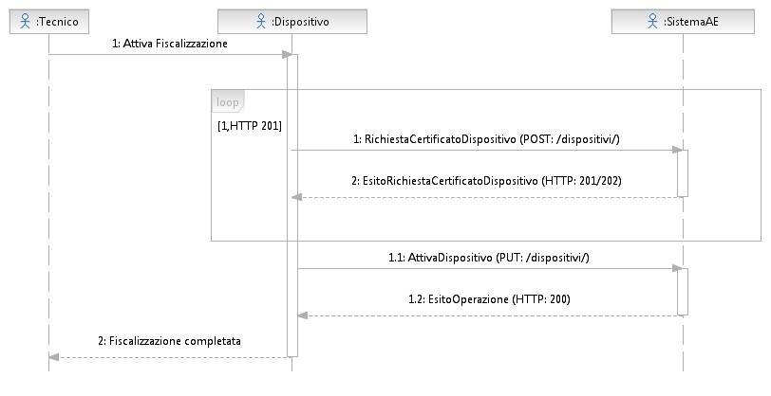

Technician Device SystemAE
1: Enable taxation
1: Device certificate request (POST:/dispositivi/)
2: Device certificate request result (HTTP:201/202)
1.1: EnableDevice (PUT:/dispositivi/
1.2: OperationResult (HTTP:200)
2:Taxation Completed

2.5 CHANGES IN THE STATUS OF THE TELEMATIC RECORDER
The operator, or his delegate, shall promptly update the data related to their RT - present in the appropriate section of the Inland Revenue website - every time an event occurs that involves a change of status of the MTR (transfer for any reason, replacement, exchange, theft, etc.).
The Telematic Recorders can initially be found in the states:
- "Censored", following the generation of the Device Certificate;
- "Activated", when the RT is registered to the AE system and is associated with an operator; "In service", when the RT has made at least one data transmission.
Subsequently, through the appropriate procedures available on the website of the Revenue Agency, it is possible to make the following changes of status for the management of possible events that may involve the RT. Specifically:
- Disposal: In case of disuse of the Telematic Recorder, the certificate of the device is revoked and the device is deleted from the registry (only such variation can be communicated also by the qualified technician through the appropriate functionalities present in the Telematic Recorder);
- Deactivation: this state entails the cancellation of the association between the Telematic Recorder serial number and the VAT number of the old operator and the suspension of the RT certificate. A relocation procedure carried out by the installer technician, through a special function made available on the device, allows to produce the request for association of the device to the VAT number of the possible new operator. This includes, for example, the transfer (for any reason - also as a result of hypothesis of substantial subjective transformations of the operator) of the telematic recorder to another operator and the theft;
- Out of Service: in case of malfunctioning not automatically communicated by the Telematic Recorder, the operator, or his delegate, can communicate on the Inland Revenue website the anomalous situation, which is tracked in the system. This status includes all the hypotheses in which the Telematic Registrar is not able to transmit data to the AE System due to causes not included in the previous points. From this state, the RT can automatically return "in service" - on the occasion of the first useful transmission, without the need for reactivation - or be "deactivated" or "disarmed". This status can also be used for the activation of the "DEMO" function.
In the following table are listed all the possible cases of detail (detail code) to be indicated as the cause of the corresponding changes of state of the device:

Consistency table: between the changes of state to be communicated and the details to be indicated
Code  detail | Detail description | Change of State  Compatible/Event
00600 | Memory depleted | OUT OF SERVICE
00601 | Other (in this case an explanatory description of the event is mandatory) | ALL
00603 | Disposal (for any reason: vs. third parties, resellers, etc.) | DEACTIVATION
00604 | Theft | DEACTIVATION
00606 | Disposal | DISMISSION
00607 | Malfunction | OUT OF SERVICE
00608 | Warehouse | OUT OF SERVICE
00609 | Summary memory exhausted or with compromised certificate | DISMISSION

In the hypothesis of accidental disuse of the Telematic Recorder, already activated or in service, or of loss of the private keys (which makes the device unusable), it is possible to restore it to its initial condition and make a new certificate request, using the "Device Restore" function in the section "Services for Managers and Operators".
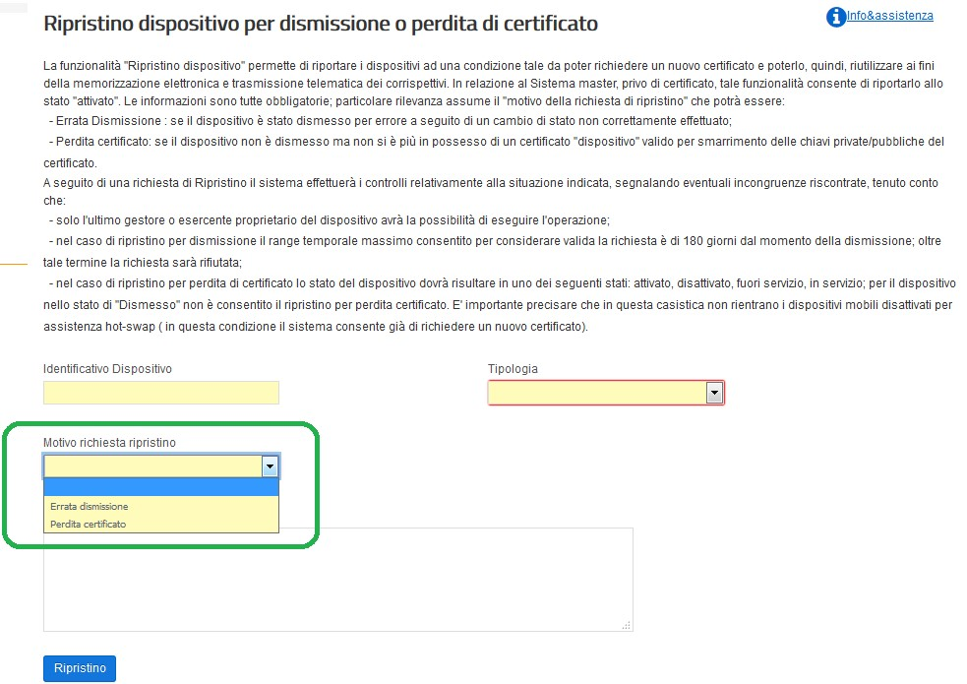

Device restore for disposal or loss of certificate.
The "Device Restore" function allows you to restore the devices to a condition that allows you to request a new certificate and then reuse it for electronic storage and telematic transmission of the fees. In relation to the Master System, which does not have a certificate, this function restores it to the "activated" state. The information is all mandatory; the "reason for the request for restoration" is particularly important:
-Dismissal: if the device has not been dismissed by mistake as a result of a change of status not correctly carried out;
-Certified loss: if the device is not disused but you no longer have a valid "device" certificate due to the loss of the private/public keys of the certificate.
Following a request for Restore the system will carry out checks on the situation indicated, reporting any inconsistencies found:
-only the last operator or operator who owns the device will be able to perform the operation;
-in the case of restoration for dismission the maximum time range allowed to consider the request valid is 180 days from the moment of dismission; beyond this term the request will be refused;
-in case of restoration for loss of certificate, the status of the device must be one of the following states: activated, deactivated, out of service, in service; for the device in "Disused" state, restoration for loss of certificate is not allowed. It is important to specify that this case does not include mobile devices deactivated for hot-swap assistance (in this condition the system already allows to request a new certificate)
Device identification number Type
Reason for restore request
Wrong divestiture
Certificate loss

Restore

The operator must enter the data required by the system, that is:
  - device identifier (RT or RT Server )
  - device type (select "Telematic recorder or RT Server")
  - reason required restoration ("wrong divestiture" or "certified loss")
  - free but mandatory description
When the "Restore" button is pressed, the System will return the device to its initial state allowing the Operator to request a new certificate in the usual manner and then activate it as if the device were "new". In order to request the new "device" certificate it is necessary to generate a new certificate request (in PKCS#10 format) as described in paragraph 2.3 on the certification process; therefore it is recommended to the Operator the utmost care in using the divestiture feature and taking care of the "device" certificate.
Since, following a recovery request, the system accepts a new census request, this makes it mandatory to recover the new QRCODE that the system produces in association with the new "device" certificate issued against the same serial number.
Please note that this operation can only be performed by the merchant who has abandoned or lost the private keys; therefore, if the TELEMATIC RECORDER is sold in the "abandoned" state instead of the correct "deactivated" state, the merchant who buys the TELEMATIC RECORDER will be unable to use it.
Therefore, it will be the responsibility of the seller, before the transfer of a used RT, to change the status of the telematic recorder to "OFF", enabling the buyer to correctly match his VAT number to the device purchased.

2.6 COMMISSIONING AND PERIODIC INSPECTIONS
The Telematic Recorder is put into service with the intervention of the authorized technician at the request of the operator or, if the Telematic Recorder is equipped with such functionality, with an automatic procedure in accordance with what has been preset by the authorized technician during the activation procedure.
Commissioning can then be carried out:
- together with the activation of the Telematic Recorder;
- after the date of activation, provided that the activation phase has already been carried out by communicating a date of commissioning.
Until the date of commissioning, the Telematic Recorder can be used by the operator as cash register in accordance with Law 26 January 1983, n.
18 in order to certify the fees, with the observance of the relevant discipline. This operation, both automatic and manually carried out by the qualified technician according to the configuration of the Telematic Recorder, will make the Telematic Recorder able to transmit the fees. At the first actual transmission the status becomes "in service".
The periodic verifications carried out by the technicians of the authorized laboratories include at least the following actions:
- Checking the integrity of the tax seal;
- control, through sample test, of the regular functioning of the fiscal module (for example, the simulation of some commercial operations and consequent verification - through reading and printing, also virtual - of the correct recording of the data in the memory remains of detail and in that of summary, as well as the closing of cash, the sending of the XML file and the feedback of the result by the AE System).
At the end of the periodical verification operations, the technician records - by means of a special function of the RT - the result of the verification carried out respecting the coding provided in table 9 of the attached "Code List". The information will be stored in the permanent summary memory and sent, together with the data of the fees, to the first transmission after the periodic verification.

2.7 DATA GENERATION AND TRANSMISSION
The Telematic Recorder or RT Server must be able to prepare, starting from the data contained in the permanent summary memory, in the working memory and in the detail memory (DGFE), any path suitable for the data to be sent.
In addition, the Telematic Recorder or RT Server will have to digitally sign the above mentioned paths with the "device" certificate issued by the Inland Revenue Agency and in compliance with security constraints.
For the interaction between the Telematic Recorder/RT-Server and the AE system, special services are displayed in REST mode, regulated by a specific application protocol for each type of communication.
The transmissions of the single files are independent from each other and therefore the Telematic Recorder/Server-RT can manage them independently from the synchronous response obtained by the AE System.
The transmission of the fees is done using a random time within the operating range of the device. All transmissions must not fall within the time range 03:00 - 05:00 antimeridian.
Simultaneously with the transmission of the xml file, the Telematic Recorder receives from the AE system the result that certifies that the validity of the seal and the formal structure of the transmitted files have been checked.
The Telematic Recorder/Server-RT must be able to interpret the response files of the transmission REST service and possibly send an alert to the user to report anomalous situations. The resolution of the transaction rejection situations is the responsibility of the Operator, who, with the support of the manufacturer and/or the qualified technician, must adapt the situation of the Telematic Recorder and re-send it. The result and, if necessary, the generated xml files or the data contained therein and transmitted to the AE system are stored in the permanent detail memory (DGFE) and are therefore available for possible consultation at the point of sale.
The results and the xml files generated for the transmission to the AE system of the data of the commercial documents participating in the lottery can also be stored in the permanent detail memory (DGFE) and thus be available for possible consultation at the point of sale.
For each transmission unsuccessful for reasons other than the delivery gap, during the day, the TELEMATIC RECORDER/Server-RT recorder must repeatedly attempt the transmission of the single file, scheduling a minimum interval between each transmission of 15/30 minutes, until the AE system takes over. In case of interruption of the activity due to weekly closure, Sunday closure, vacation, closure for exceptional events, seasonal activity or any other hypothesis of interruption of the transmission (not caused by technical malfunctions of the device), the MCR, at the first subsequent transmission or at the last useful transmission, will process and send a single file containing all the data (at zero amount) related to the period of interruption, for which the operator has not carried out the daily closure operation.
For technical details of the data format and application protocol, please refer to Chapter 4, paragraphs 4.2 and 4.1 respectively.
In order to allow users to manage verification situations on the systems, the transmission of daily fees includes the possibility of making test shipments for any reason.
The "Test Sending" mode - optional - must comply with the following constraints: Each start and end of the "trial sending" mode must be plotted in the summary memory together with the start/end date and time; it must also be possible to consult the fiscal memory section where the start and end of trial sending are recorded;
- Each commercial document must be generated/printed by replacing all spaces with the character "?" (question mark) and must contain the words "COMMERCIAL TEST DOCUMENT"; in the header.
Without the use of the logo type
- The "send test" mode:
  - it previews the transmission of data toward the System AE while all the other operations are merely simulated; to such purpose it is necessary to set in the trace xml of the correspondents to transmit the appropriate attribute simulation='true' in the tag, first tag, that allows to classify the type of sending as "of test". In all the cases in which such attribute turns out absent the sending will be considered real.
  - can be enabled in the states of the telematic recorder "in service" or "activated"; in the latter case after sending the device will be in service;
  - Daily closures in "trial sending" mode should not be saved in the summary memory and will not be counted as real daily closures. In the detail memory, instead, the commercial documents will be saved in a special section in the same way they are printed ("?" character instead of spaces) as well as the generated XML files and those containing the result of the sending.
It is important to point out that test consignments must be carried out in a controlled and reduced manner, in periodic checks and in strictly necessary situations.
The data for which it is responsible are processed and made available on a dedicated area of the Revenue Agency's website for the benefit of individual operators, manufacturers, each on the basis of a specific profiling.
In particular, on the website of the Inland Revenue Agency, the operator can consult the information related to its Telematic Recorder at any time. In detail:
- Manufacturer's data: name or surname/first name, fiscal domicile and tax code/VAT number;
- Data of the Telematic Recorder: brand, model, serial number, details of the approval measure;
- User data : name or surname/first name, fiscal domicile and tax code/VAT number;
- Data of previous users: name or surname/first name, tax code and
VAT number;
- Date of activation;
- Date of commissioning;
- Interventions of the qualified technician: technical CF, VAT number of the laboratory for which they work, date of intervention, type of intervention
- List of status changes.
For the details of the item "typology of intervention" refer to table 9 of the attachment "Attachment - Code List".

2.7.1 DAILY FEES
At the time of the daily closing, by processing the data contained in the permanent summary memory, the telematic recorder or RT Server generates an xml file according to the path shown in the attachment "Attachment - Data Types for Fees - version 7 - June 2020".
In particular, the Telematic recorder or RT Server, in particular, must be able to manage the correct differentiation of the values of the "uncollected" fees referred to the transfer of goods or services, gifts, and operations certified subsequently with invoices. Moreover, it must manage the number of commercial documents issued during the period and the types of payment used (cash and electronic), the information referred to the acceptance of tickets and vouchers invoiced to third parties and any information referred to the discount recognized only at the time of payment. The Telematic Recorder shall be able to manage, in case of payment in full in cash, the rounding off provided for by art. 13-quater of D.L. n. 50/2017 without the need to report this information in the data to be transmitted with the attached "Attachment - Data Types for Fees - version 7 - June 2020".
In cases where the operator operates with more than one activity code, the telematic recorder must allow the operator to charge the data of the fees specifying the activity for which it is carrying out the operation, so as to allow the correct reporting of the fees and the related tax for each activity.
The recapitulative statement blocks of the fees by VAT rate/nature are contained in the daily working memory and saved during the closure in the detail memory as defined in the annex "Annex - Data Types for Fees - version 7 - June 2020".
The supplies must be sequential, i.e. a progressive transmission must be sent, unique for each MCR.
The data of the fees transmitted will be considered to refer to the date reported in the field <DateReview> of the attachment "Attachment - Data Types for Fees - version 7 - June 2020". In the event of cash closure after midnight on the opening day, in order to correctly allocate the data of the fees and VAT settlement - especially with reference to the days between now and the end of the settlement period - it will therefore be useful to make a first cash closure within midnight on the opening day.
The daily data transmission takes place with a variable frequency within 12 days from the date of storage of the fees, which coincides with the date of execution of the operations.
Files cannot exceed the maximum size of one megabyte.
The Telematic Recorder, if it is not able to transmit the files to the AE system due to lack of connectivity, can transfer the electronically sealed file to an external device or use the appropriate features available on the "Invoices and Fees" portal of the Inland Revenue's website to make the transmission in order to comply with the terms of this provision. In this case, the result of the transmission is transmitted to the external device and can still be consulted within the dedicated area of the website of the Revenue Agency. If the AE system detects an error in the transmission or in the data format, the result of the error is sent in accordance with the "Transaction Outcome" element according to the layout defined in the attachment "Attachment - API Device and Management Data Types" and the coding defined in the attachment "Attachment - Code List".
If the operator identifies an incorrect or partial data collection and/or transmission due to malfunctioning of the telematic recorders or to third parties not attributable to the RTs themselves, he can report such anomaly through the appropriate online procedure available on the Revenue Agency website or through the appropriate REST service made available. It is not possible to send corrective files of files already transmitted.
The AE system makes it possible to carry out "Test Submissions" with the aim of testing the correctness of the telematic data transmission process. Once this test phase is completed, the qualified technician will simultaneously carry out: 1) the shutdown of the RT; 2) the reset of the device in "Cash Register" in accordance with Law no. 18 of 26th January 1983, in order to certify the fees, with the observance of the relevant discipline.

2.7.2 COMMERCIAL DOCUMENT FOR LOTTERY PURPOSES
Please refer to the decision of the Director of the Revenue Agency of 31st October 2019.

2.8 EMERGENCY PROCEDURES
In the web portal Invoices and Fees there are features that allow to manage some emergency situations in the use of the Telematic Recorders for the storage and transmission of the fees.

The functionalities are made available, in the "Fees" area, both to individual operators and to their specially delegated intermediaries (in this regard, please refer to the provision of 5th November 2018 and subsequent amendments) and concern the following situations:

- absence of internet network and/or connectivity problems of the device, in this case it will be possible to upload the file prepared, sealed and extracted from RT;
- device out of service, in this case it will be possible to manually allocate the data of the fees that could not be stored and transmitted due to the RT failure. To transmit the data it is necessary that the serial number of the device has been promptly put in the "out of service" state;
- recovery of some situations of rejection of the transmission of the daily fees.
These emergency functions can be found in the section "Services for Managers and Merchants", with dedicated submenus for emergency procedures.

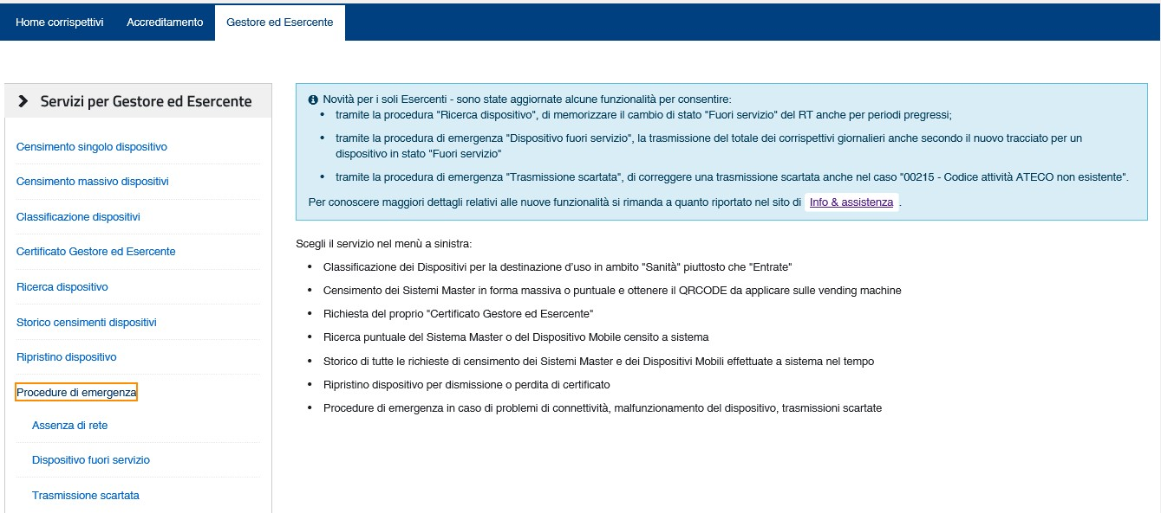

No network
The function is intended for operators who are unable to transmit, within the 5 days indicated in the Provision of the Director of the Revenue Agency of 28.10.2016, the XML file of the fees correctly prepared and electronically sealed by the device.
The data of the fees transmitted will be charged to the operator who at that time is the owner of the device, regardless of the person who makes this transmission, as this function is aimed solely to allow the sending of a file already properly prepared by a Telematic Recorder / RT-Server although the same is impossible to do so.

Sending fees files
Select and transmit the signed fee file.
Browse
No file selected
Send

2.8.1 LACK OF INTERNET NETWORK AND/OR DEVICE CONNECTIVITY PROBLEMS

(UPLOAD FILE EXTRACTED FROM RT)

The functionality is intended for operators who are unable to transmit, within the time limits indicated in the Provision of the Director of the Revenue Agency of 28.10.2016, the XML file of the fees correctly prepared and electronically sealed by the device, after data storage. In fact, in case the device is correctly working but there are network problems, due to the internet operator used and/or the connectivity of the device, it is possible to transmit the fees through the online function "No network". In this case the Telematic Recorder must memorize the receipts and prepare the appropriate XML file of the fees, including the electronic seal affixed with the device certificate. Since the device is not able to recall the transmission services to send the daily fees to the Revenue Agency, the operator can extract the sealed XML file, by means of the appropriate functionalities of the device, and transmit it using the new function of the Fees system through the new menu item "Emergency Procedures > Network Absence", available in the section "Manager and Operator Area".

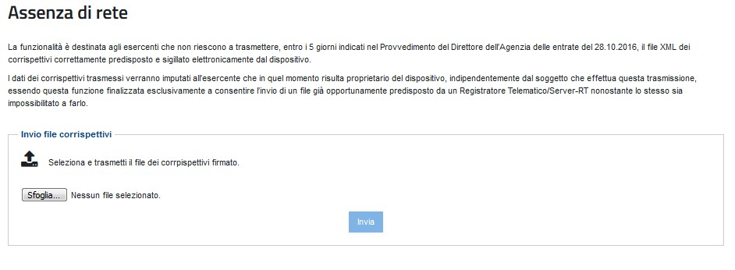

Using the "Browse" button the user can then select from their workstation the corresponding file to be forwarded.

The data of the fees transmitted will be charged to the operator who at that time is the owner of the device that is the signatory of the xml file, regardless of the person who makes the transmission. In addition, this mode of transmission will be appropriately classified as "transmission by upload" in order to distinguish it from direct transmissions by telematic recorder.

Please remember that the functionality has only an emergency value and therefore should be used only in case of actual need.

2.8.2 OUT OF SERVICE DEVICE (DATA ACQUISITION)

The functionality allows you to manage the transmission of data of the fees for devices with malfunctions that prevent the electronic storage of the fees.

In this regard, reference is made to the provisions of point 5 of Measure of the Director of the Revenue Agency No. 182017 of 28.10.2016 and those of the paragraph
2.5 of this technical specifications document, recalling that "in case of failure or irregular functioning, for whatever reason, of the MCR, the operator promptly requests the intervention of a qualified technician and, until its correct functioning is restored or it is equipped with another MCR regularly in service, it provides for the recording of the data of the fees of the single daily operations on a special register to be kept also in computerized mode".

To deal with this type of situations, the operator can access the function through the menu item "Emergency Procedures > Out of Service Device", available in the "Manager and Operator Area" section.

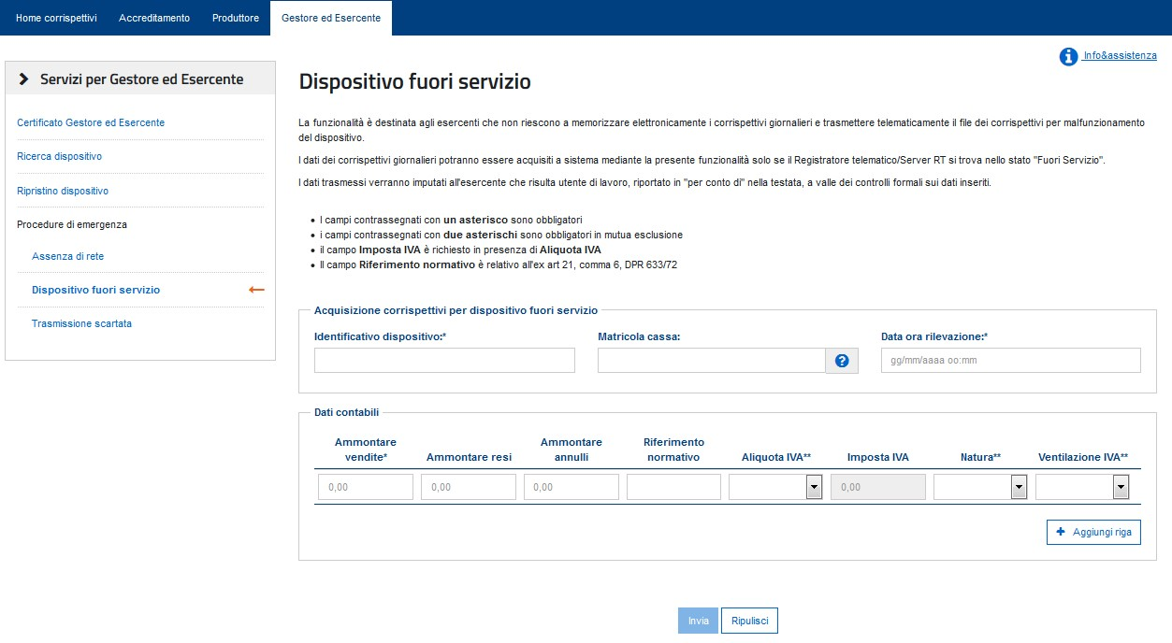
Home correspondents Accreditation Manager and Merchant

Services for Manager and Operator
Manager and Operator Certificate
Device Search
Device Restore
Emergency procedures
No network
Device out of service
Discarded transmission

Device out of service
The function is intended for operators who are unable to electronically store the daily fees and transmit the file of the fees for device malfunction.
The data of the daily fees can be acquired through this functionality only if the RT server/telematic recorder is in "Out of Service" status. The data transmitted will be attributed to the operator who is a working user, reported in "on behalf of" in the header, after the formal checks on the data entered.
- fields marked with an asterisk are mandatory
- fields marked with two asterisks are mandatory in mutual exclusion
- the VAT tax field is required in the presence of VAT rate
- the field Regulatory reference is related to ex art. 21, paragraph 6, DPR 633/72

Acquisition fees for device out of service
Device Identified
Serial number
Date time detection
Accounting data
Sales Amount
Returns amount
Amount of cancellations
Regulatory reference
VAT rate**
VAT tax**
Nature**
VAT Ventilation**
+ Add line

Send
Reset

The graphic interface allows the operator to transmit to the Revenue Agency the aggregated data of the daily fees per VAT rate/nature (i.e. indicating the adoption of the "ventilation" regime) that he should have transmitted with the telematic recorder, in compliance with the XML path represented by the "Annex - Data Types for Fees version 7 - June 2020" of the Technical Specifications of the measure of 28.10.16.
Through this interface it is possible to transmit fees only if, for the indicated device, the status of "out of service, regardless of the current status, in relation to the date of the fee you want to acquire.

This mode of transmission of daily fees will be appropriately classified as "transmission by out-of-service device" to distinguish it from situations with fiscal data stored electronically in the telematic recorder and transmitted telematically by the device itself.

It is therefore specified that this functionality can be used only in cases of actual need and only after having communicated to the system the status
"out of service" of the telematic recorder.

2.8.3 DISCARDED TRANSMISSIONS RECOVERY

The functionality allows the recovery of some discarded transmissions, which fall exclusively in specific cases: if the amount sent is discarded by the AE system, due to the setting of the "DataReview" or due to the absence of the serial number of the cash point connected to the RT Server, or due to the non-existent ATECO Code, a new transmission of the same accounting information can be avoided by proceeding with a recovery of the discarded situation.

The online "Discarded Transmission" function allows the operator to recover only the following situations:
- 00203 - Date in the future on the DataDateDetection element - 00212 - The Transmit/Device element is mandatory.
- 00215 - ATECO activity code not existing

No changes will be made to the accounting information sent and this recovery will be appropriately classified.

The operator can access the function through the new menu item "Emergency Procedures > Discarded Transmission".

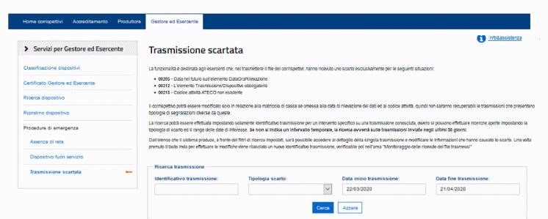

Can’t read

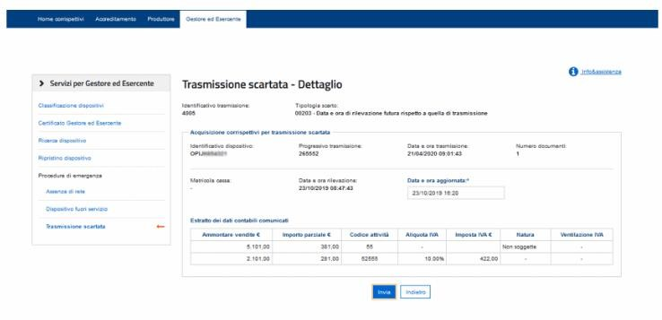

Can’t read

2.9 ONLINE BUSINESS DOCUMENT

The subjects who carry out the operations referred to in Article 22 of Presidential Decree no. 633 of 26th October 1972 can use the new line dedicated to the generation of the commercial document, with production of the pdf version to be released to the customer.

The compilation of the commercial document is available on the website of the Revenue Agency through the access to the Invoices and Fees portal, where on the home page there is a special management line in the Fees area. The service is available exclusively for the operator (it is not possible to delegate the use of the service to intermediaries referred to in art. 3 of Presidential Decree no. 322/98) and, if the latter is a company, the service can be used by appointed operators through the functions available on the telematic services of the Revenue Agency.

This compilation is structured in four successive phases:
- My data, where I can insert the personal data of the subject already partially filled.
- Document data, where to insert the accounting information of the operation and, where communicated by the customer, the lottery code;
- Verification, as a representative element of the commercial document to be produced
- Confirmation and printing, for protocol and assignment of the unique identifier to the document and production of the file for the customer.

The system also manages return and cancellation documents. For the latter, the original commercial document, previously acquired with the same function, must be recovered.

The document can be modified in all its parts until confirmation, which assigns a progressive number and consolidates the information.

Below is an example of the commercial document produced in pdf format:

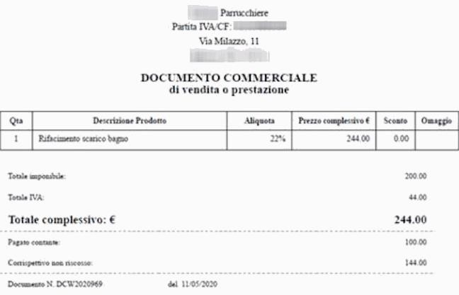

Hairdresser
VAT/CF:
Via Milazzo, 11
COMMERCIAL DOCUMENT
of sale or service

Qta
1

Product Description
Bathroom drain refurbishment

Rate
22%

Total price €
244,00

Discount
0.00

This document can be printed or sent in electronic format to the customer.

In the same line there is also a display function that, after a selective search on all the user's business documents, you to search the detail of the single document inserted previously. It is always possible to reproduce the file in pdf format representative of the document.

2.10 ADAPTING CASH REGISTERS FOR STORAGE PURPOSES

ELECTRONIC AND TELEMATIC TRANSMISSION OF THE DATA OF THE FEES

All cash registers models produced on the basis of a provision of the Director of the Inland Revenue Agency for approval of the model, valid as of 1st January 2017, can be made compliant with these technical specifications and adapted to Telematic Registrars with the introduction of hardware and software changes that must be documented in a variant application to be submitted to the Inland Revenue Agency. This application follows the same approval process as in paragraph 2.2, except as indicated in the "Attachment - Technical prescriptions for approval"; in fact, the technical prescriptions described in the approval process for the adapted cash registers, as per Law no. 18 of 26th January 1983 and art. 12, paragraph 1, of Law no. 413 of 30th December 1991, apply to the adapted cash registers.
The cash registers referred to in Law no. 18 of 26th January 1983, art. 12, paragraph 1 of Law no. 413 of 30th December 1991 and subsequent implementing regulations, may be used for the electronic storage and telematic transmission of the data of the fees referred to in art. 2, paragraph 1, of Legislative Decree no. 127/2015 under the following conditions:
a) if they meet the following characteristics
- are equipped with connectivity;
- store the device certificate in the permanent summary memory;
- process, also by means of a special software update and electronically seal - by means of the fiscal firmware - the xml file prepared for the fees data according to the structure of the attachment "Attachment - Data Types for Fees - version 7 - June 2020".
b) if they do not meet the characteristics referred to in point a):
are equipped with a special external device, connected to the cash register and controlled by its fiscal firmware. Said apparatus is defined "sending module" and must include a secure and dedicated memory to contain the device certificate and all the parts of the "fiscal module" referred to in paragraph 2.1, with the exception of the permanent memory, if the related functions are performed by the fiscal memory and the DGFE already present in the Cash Register. The connection between the sending module and the Cash Register must provide a mutual authentication protocol and guarantee an adequate level of inalterability and confidentiality of the data exchanged.
The sending form must have technical characteristics such as to guarantee the authenticity and inalterability of the data transmitted.
The device must be uniquely identified by a "serial number" with a format similar to that indicated in letter c) in the paragraph "Hardware and software features" for the MCR, where the third character is enhanced with the letter "M".
This unique identifier must be included in the certificate request in PKCS#10 format, which the manufacturer installs in the single device in analogy to what happens in the Telematic Recorder.
When activating the sending form connected to a cash register, the authorized technician also sends two device identifiers, that of the sending form for the certificate request and that of the cash register for the census. The cash register identifier is a piece of information explicitly inserted in the activation request, while the identification of the sending form is automatically present in the certificate request connected to the activation phase.
In addition, the Cash Register - including the dispatch form - used as a Telematic Registrar is subject to the indications provided in the previous paragraphs with reference to the approval and certification process, activation, commissioning, status changes and data transmission.
In relation to the technical requirements for the approval of equipment models
Telematic recorders referred to in the attachment "Attachment - Technical requirements for approval", the submission form is subject exclusively to the verification of the installed fiscal software and to the evaluation of the reliability of components, plates and modules (MTBF) referred to in paragraph 1.1 of the attachment "Attachment - Technical requirements for approval".
Updated or integrated cash registers as indicated in letters a) and b) can be used by merchants as Telematic Recorders until the completion of the fiscal memory or its possible failure.
Cash Recorders can be adapted to the new model of Telematic Recorder, not only during production, but also during operation, through the appropriate hardware and/or software modifications. As a result of these modifications, the single device complies with the new model of Computer Recorder and must therefore be "registered", then "activated" in case it is in the possession of an operator, and "put into service" from the moment in which the operator makes the first transmission of the data of the daily fees.
A specific function, manual or programmable, must allow the operator to use the recorder as "telematic" and no longer "cash". This function must be used by the operator - in the awareness of having an "active" RT - in such a way that, immediately after the last daily closing of the Cash Register, the Telematic Recorder no longer issues tax receipts but commercial documents. The same function, if the legal conditions exist, must allow the same to return to use the "telematic" recorder as a "cash" recorder.
In the permanent detail memory must be recorded, with a clear sign of discontinuity, the operation of switching from MF cash register to RT telematic recorder, and vice versa.

2.11 MANUFACTURERS OF TELEMATIC RECORDERS
Manufacturers of Telematic Recorders must accredit themselves through a special online procedure available on the website of the Revenue Agency.
Once accredited, hw manufacturers must apply to the Revenue Agency for the issuance of a signature certificate (called "Manufacturer Certificate"), necessary to carry out activities requiring the affixing of an electronic seal.
If the manufacturer, for any reason (e.g. loss of the private key, theft of the certificate, etc.), is no longer in possession of a valid certificate and, therefore, needs to request a new certificate, it must first use the "certificate cancellation" feature; only after cancelling the previous certificate, in fact, it is possible to request a new certificate in the ordinary way.
The certificate cancellation function can be found in the "Manufacturer's certificate" section under "Services for Manufacturers".
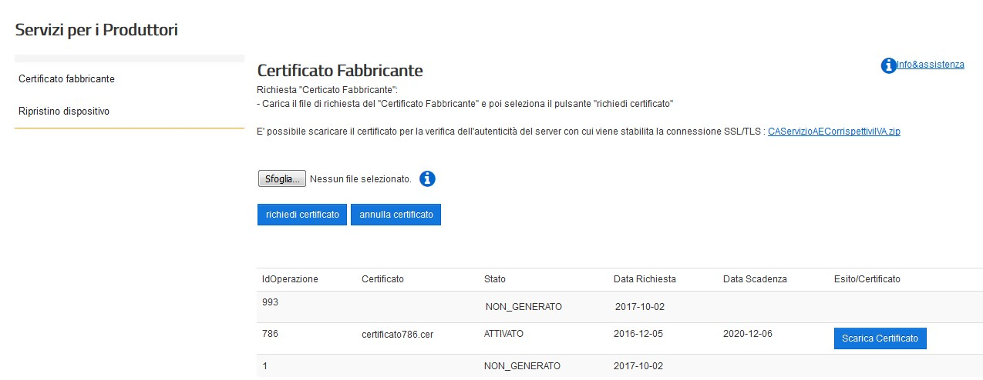 Services for Manufacturers

Manufacturer's certificate
Device Reset

Manufacturer Certificate
Request "Manufacturer Certificate":
- Upload the "Manufacturer Certificate" request file and then select the "request certificate" button

You can download the certificate to verify the authenticity of the server with which the SSL/TLS connection is established: CAServizioAECorrsipettiviIVA.zipper
Browse
No file selected
Request certificate
Cancel certificate

IdOperation
Certificate
Status
NOT_GENERATED
ACTIVATED
Request Date
Expiry Date
Results/Certificate
Download Certificate

WARNING: in case of cancellation of the "manufacturer's certificate" all the manufacturer's RTs sold and already activated in the system can still continue to operate.
On the contrary, the manufacturer's RTs that already contain a "device certificate request" signed with the cancelled "manufacturer certificate" will no longer be able to be activated in the system and thus be operational.
We therefore recommend that manufacturers take the utmost care when using this feature.
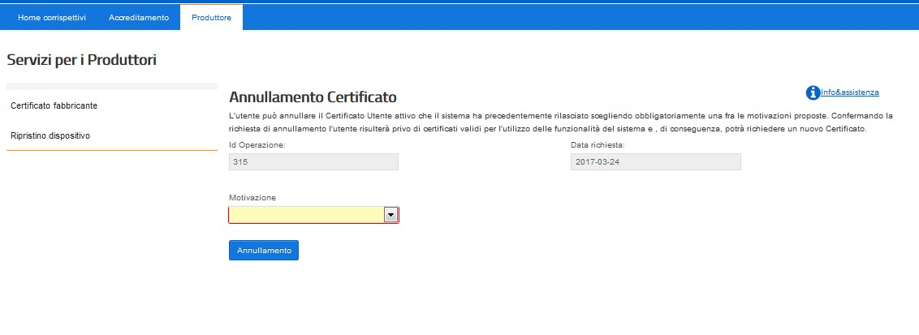

Service for Manufacturers
Manufacturer's certificate
Device Reset

Device Reset
The manufacturer can bring back to the initial state the devices, which have already been registered (for which the system has already issued a valid certificate), but not yet activated. The restoration of the device presupposes the loss of the valid "device" certificate; all the fields in the screen must be filled in.

Device ID
Type

Certified loss

Description (maximum 500 characters)
Restore

The manufacturer also has at its disposal an additional "Device Restore" feature that is useful in case of loss of private keys (which makes the device unusable): this feature allows to restore the RT to the initial condition and make a new certificate request, only if no activation has occurred on the device.
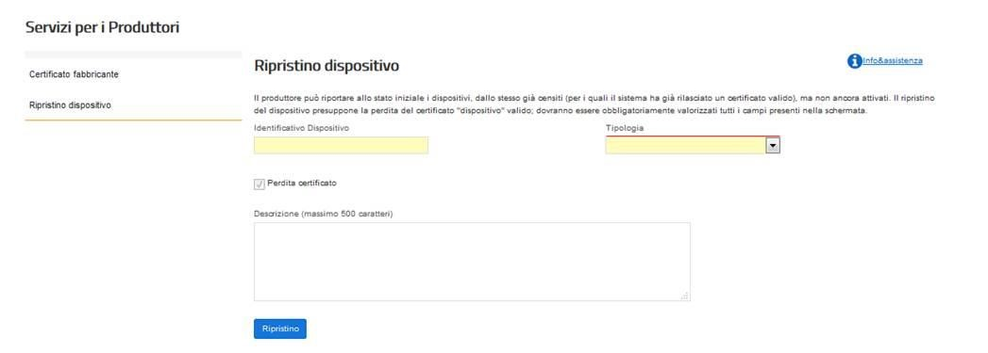

When the "Restore" button is pressed, the System will return the device to its initial state allowing the Manufacturer to request a new certificate in the usual way, as if the device were "new". In order to request the new "device" certificate it is necessary to generate a new certificate request (in PKCS#10 format) as described in paragraph 2.3 on the certification process; therefore we recommend the utmost care in the care of the "device" certificate.
Since, following a recovery request, the system accepts a new census request, this makes it mandatory to recover the new QRCODE that the system produces in association with the new "device" certificate issued against the same serial number.

3. OPERATORS WITH MULTIPLE CHECKOUT POINTS PER SINGLE POINT OF SALE
For merchants who operate with a number of not less than three cash points per single point of sale and who meet the requirements listed below, the storage and telematic transmission of the data of the daily fees of the individual cash points may be carried out through a single "collection point".
Cash point" means a system located at the point of collection of the fees, consisting of hardware and software for sales management able to transmit the data referred to the generated documents (commercial documents or invoices) to the RT server. The obligation of transmission does not exist with regard to the eventual graphic logo and non-fiscal information generated after the detail of the payments. In order to comply with the provisions of art. 1, paragraph 4, of the Ministerial Decree of 7 December 2016, the cash point may be equipped with a printer (non-fiscal) for the issue and release of the paper commercial document to the customer.

For "Point of sale" means - in accordance with the indications of practice already provided (Circ. Agenzia delle Entrate n. 8/E of 23/02/2006, par. 3.3, n. 3) - the local unit identified by:
- the Economic Administrative Directory (REA) number assigned by the Chamber of Commerce;
- the order number assigned to the headquarters by the Chamber of Commerce, within the Economic Administrative Directory;
- the indicative of the municipality, the province and the address.
The "collection point" consists of a Telematic Recorder connected to the individual cash points which, notwithstanding the provisions contained in letter d) of 2.1 of this document, does not necessarily contain a printing station inside the casing.
In the event that at the single point of sale there is a management server that already operates the consolidation of the data of the individual cash points, the merchant may choose to make the hardware and software changes to this device such as to make it compliant with these technical specifications, so as to use this consolidation server for electronic storage and telematic transmission of data of the fees referred to in Article 2, paragraph 1, of Legislative Decree no. 127/2015 (see paragraph 2.8).
Alternatively, if the consolidation server cannot be adapted to the Telematic Recorder, it is possible to connect an RT to the consolidation server, providing between the machines an internal data exchange protocol that guarantees an adequate level of inalterability and confidentiality of the exchanged data.
In the latter two cases, the collection point is called "Consolidation Server-TV Server" (hereafter, only Server-RT). The Server-RT - allocated at the single point of sale - is always the first point where the corresponding amounts are collected and is the tool that seals the files and sends them to the AE system. In addition, at the point of sale there must necessarily be a workstation connected to the RT server and equipped with printer, from which the control staff - through special credentials - can at any time access all the functions provided by these technical specifications, including printing.

In particular, the Server-RT contains or is connected to a "tax module" as defined in paragraph 2.1 above.
The tax form of the RT-Server is univocally identified by a "serial number" with a format similar to the one indicated in paragraph 2.1 for the Telematic Recorder, in which the third character will be enhanced with the letter "S".
Also the individual cash points are identified with a serial number, assigned by each operator, which must be communicated between the data to be transmitted electronically in accordance with the path provided in the "Attachment - Data Types for Fees - version 7 - June 2020" in correspondence of each daily transmission.
The serial number of the checkout point is univocal and consists of a group of 8 characters composed as follows: the first four alphanumeric characters identify the point of sale; the following four numeric characters identify the checkout point present in the point of sale. The uniqueness of the freshmen and their correct assignment to the single checkout points must be subjected to the internal control process by the merchant.
The uniquely identified cash points must be registered on the RT-Server, on which the map of the cash points connected to it is defined.
This map must be created and kept constantly updated by the operator, through automatic or manual operations. The changes of the map constitute administration operations of the Server-RT which must therefore be recorded in the permanent detail memory reporting at least the following information:
- date and time of the operation;
- identification data of the person who carried out the operation (the operator of the operator or the qualified technician for manual operations, the operator for automatic operations);
- data related to the content of the operation.
The individual cash points from which the data of the fees originate must be connected directly, or through the consolidation server present in the store, to the RT, providing in particular an internal data exchange protocol that guarantees an adequate level of inalterability and confidentiality of the exchanged data. For this purpose, in case of remote connection between RT Server and Cash Points, a secure VPN network can be used (such as, for example, in the case of Trusted VPN, the MPLS level 3 or, in the case of Secure VPN, the IPsec).
The Server-RT must allow the export or the printing, also virtual, not only of the information mentioned in point 2.1 letter d) but also of the information related to the operations carried out by the single cash point.
The indications given in paragraphs 2.2, 2.3, 2.4, 2.5, 2.6 with reference to the approval and certification process, activation, commissioning, status changes and data transmission apply to the Server-RT.

With reference to the application of the QR Code as per paragraph 2.4, in the case of subjects with more than one cash point per single point of sale, the same must be applied, also directly by the merchant, both on the Server-RT and on the single cash points connected to it.
With particular reference to the case of failure of the Telematic Recorder (i.e. of the RT-Server), the provisions contained in paragraph 2.7 above apply. In no case does this interruption lead to the suspension of sales activities.
In the process of transmission of the data of the commercial documents from the single cash points to the Server-RT, errors may occur, which must be reported with appropriate alarms to the operator, who must immediately take action for their resolution, requiring, if necessary, the intervention of a qualified technician.
These errors must not cause the interruption of the operation of the cash point but, as far as possible, they must be solved through automatic mechanisms or through appropriate punctual checks; in any case, in order to allow the subsequent checks, any anomaly that has occurred must be recorded in the permanent detail memory of the RT-Server and information must be sent to the Agency through the compilation of section 7 <Reporting>, indicated in the attachment "Data types for fees - version 7 - June 2020", with the following information:
- Serial number: identification number of the cash point involved in the event;
- DateTime: date and time when the last abnormal event of the day occurred for the indicated cash point;
- Code '02': this code corresponds to a generic "cash point anomaly", where the cash point is the one indicated in the above field <Matricola>.
- Notes: free field for any additional description of the event
The consultation of the anomalies must be allowed through specific service functions available on the Server-RT.
Merchants that operate with more than one cash point per single point of sale and that carry out the electronic storage and telematic transmission of the data of the fees of the single cash points through a single RT or a Server-RT must have them certified by a person duly registered in the Register of Statutory Auditors kept by the Ministry of Economy and Finance, in application of the Legislative Decree n. 39/2010 (e.g. Auditing Firm) the control process referred to in the following paragraph, which must be consistent with the internal control system adopted on the basis of the "Organization, Management and Control Model" of Legislative Decree no. 231 of 8th June 2001, where applicable.

The internal control process must be declared compliant with the requirements indicated in this paragraph both with reference to administrative and accounting processes and with reference to the company's IT systems involved in the storage and telematic transmission of fees. The compliance of the administrative and accounting processes must be carried out by a person duly registered in the Register of Auditors kept by the Ministry of Economy and Finance, in application of Legislative Decree no. 39/2010 (e.g. Auditing Firm); for the compliance of the computer systems involved in the storage and telematic transmission of the fees, the operators may apply both to a person registered in the Register of Auditors and to the Entities (University Institutes and CNR) authorized to issue the certifications referred to in point 2.2 of these technical specifications.
The above mentioned internal control processes and compliance audits are performed at least every 3 years.
If the merchant's points of sale adopt, for the computer systems involved in the telematic storage and transmission of the fees, the same RT servers as well as interview and application software related to the management and transmission of fiscal data functionally equivalent, the merchant may limit the verification of compliance of the systems to a single point of sale and this control will also apply to other points of sale with the same characteristics. To this end, the merchant self-certifies the points of sale that adopt the same configuration as the point of sale already equipped with a conformity certification.

The control process must comply with at least some minimum requirements, including the verification that each sales document (consideration) corresponds to a collection in its various forms (cash, credit cards, ATMs, checks, etc.). The control is carried out at the level of the individual "cashier"/"cashier"/"forms of payment" and all differences/exceptions must be reconciled and supported by due documentation which must be kept electronically, in accordance with the Ministerial Decree of 17 June 2014, for 10 years and made available to the auditing bodies of the Financial Administration in case of control activities.
The internal control process must be structured in the following phases and the company must maintain a description of it in specific internal administrative documentation (including IT) which must be stored electronically in accordance with the provisions of the Ministerial Decree of 17 June 2014.
- At the closing of the last cash point, a document is produced containing the day's financial report of the point of sale, which is made up of the summary by totals of the reports of the individual cash points. In this document are highlighted, separated by cash point:
˗ the total fees;
˗ the total amount collected by type of payment (cheques, cash, credit card, bancomat, etc.).
- Subsequent to the operations described in point 1. a special detailed report is prepared that allows the squaring and verification of the fees.

4. TECHNICAL NOTES
The devices responsible for the storage and transmission of data of the fees must be able to generate and interpret files in xml format, on which an advanced electronic seal is affixed, produced by means of a signature certificate issued by the CA of the Revenue Agency. In addition, they must be able to transmit and receive, in telematic mode, to and from the Revenue Agency, the above mentioned files, through a connection to the public internet.
The device components that perform storage and transmission can be distinguished and physically separated.
In order to be able to transmit the data of the fees, the device must be activated, associated with the VAT number of the person holding the fees and put into service.
The process is represented in the following diagram/flow:
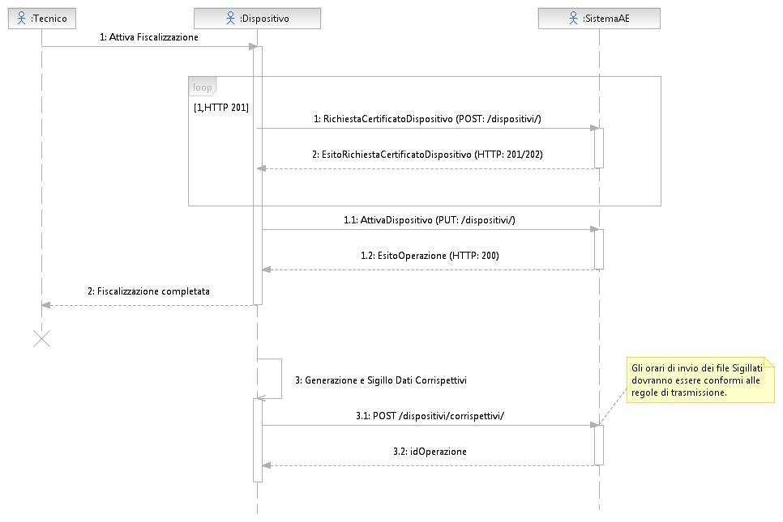

Technician Device SystemAE
1: Enable taxation
1: Device certificate request (POST:/dispositivi/)
2: Device certificate request result (HTTP:201/202)
1.1: EnableDevice (PUT:/dispositivi/
1.2: OperationResult (HTTP:200)
2:Taxation Completed

3:Generation and Sealing Data Corresponding Data

3.1: POST/devices/correspectives/

3.2: idOperation

4.1 SERVICES
Below is the list and summary description of the services:
a) Manufacturer/exhibitor accreditation
- A natural person authenticates himself at the website of the Inland Revenue and requests a certificate as a manufacturer, communicating his VAT number or that of the company he represents; the AE system verifies the suitability of the request, checking in the Tax Registry the tax identification (VAT number). In case of positive verification the AE system issues a certificate, the so-called "manufacturer" certificate.
- A natural person authenticates himself at the website of the Revenue Agency as an operator, communicating his VAT number or that of the company he represents; the AE system verifies the suitability of the request, checking in the Tax Registry the tax identification (VAT number). In case of positive verification, the AE system allows access in order to retrieve the QRcode for each device in its possession.

- Device Census
  - The AE system provides a service that can only be called up from the device to request the certificate associated with the device itself, the so-called "device" certificate. This functionality is used in the activation phase of the device, through the "manufacturer" certificate, and allows the data entry in the registry for the census. This mode will also be usable by the sending form used for the adjustment of the cash register.

- Device activation
  - The AE system provides a service, which can be called up via the "device" certificate, to communicate the activation data of the device. The AE system associates the device to the VAT taxable person holding the fees and the status of the device is updated as "Active".

- Transmission of fees (commissioning of the device)
  - The AE system provides a service, which can be called up by means of the "device" certificate, which allows the data of the fees to be transmitted. With the first transmission the status of the device is updated as "In service".

- Device Management
  - The operator, authenticated to the website of the Inland Revenue, can communicate changes in the status of devices associated with their VAT number: transfer, theft, failure, etc ...

The "Rest" APIs describing the service interfaces can be found in the following attachments:
    - Attachment - Api Rest Devices, for all services that can be called from the devices exposed to the Revenue Agency with the address "https://apidivaservizi.agenziaentrate.gov.it/v1/dispositivi/". The same services can be used for the transmission of daily fees to the health system using the address "https:// apid.sanita.finanze.it".
    - Attachment - Api Rest Gestionali, for all the services that can be recalled from the management systems exposed to the Revenue Agency with the address "https://apig-ivaservizi.agenziaentrate.gov.it/apig/v1/gestori/".

4.2 DATA FORMAT
The paragraph refers to the totality of the formats for the different needs of the system, then the detailed attachments for the structure of the xml files output and input from the device are referenced.
The most significant XML formats are listed below:
- Certificate request for a device
- Results of the certified request for a device
- Activating a device
- Transmission of fees.
The information content of this file includes the information to be reported obligatorily as relevant for tax purposes for daily fees. In addition, the information identifying the transmission and the source device of the fees that are being transmitted and the information relating to any maintenance work carried out by the qualified technician are provided.
- Result of the device activation or data transmission operations of the
correspondents
- Signaling from device

The detail of the structures of the single message, which the device exchanges with the AE system, is shown in the following attachments:
- Attachment - API Data Types Devices and Management
- Attachment - Data Types for Fees - version 7 - June 2020

4.3 EXPERIENCE CODES
The detail of the code list covering the different cases listed is represented in the document "Attachment -Code List (version 10)".

If the device allows it, in case of fiscal receipt issued by Fiscal Meter, it is always possible to use its serial number as reference.
In this context, "user" means the operator using the Telematic Recorder.
This is the case, for example, of operations regulated by agreements: a restaurant that enters into an agreement with a company and provides meals every day to the employees of the latter by issuing an invoice summarizing the individual meals at the end of the month and by issuing commercial documents for uncollected consideration to the individual employees at the end of each month.
This is the case in which the merchant voluntarily decides to register the total consideration but to charge the customer a lower amount. In this case, please note that the consideration (taxable and VAT) to be accounted for is always gross of the "discount to pay". What is different, instead, is the discount on the single operations that can always be managed during the storage phase.

